Patterns of utilization, expectations, and satisfaction of the community to urban health extension services

Damen Haile Mariam¹, Berhan Tassew¹, Adiam Nega¹, Demeke Assefa¹, Dawit Siraw¹, Yibeltal Tebekaw², Hibret Alemu², Mesfin Addisie¹

Abstract
Background: The Urban Health Extension Program (UHEP) – an innovative Ethiopian government plan to ensure health service equity by creating demand for essential health services through the provision of appropriate health information at the household level – is one of the three approaches of the national Health Extension Program (HEP). There are very few studies on the quality of health care provided by the UHEP in Ethiopia. This study is part of a comprehensive survey designed to assess the quality of health service delivered by the UHEP, and looks at the pattern of utilization, expectations, and satisfaction of the community in relation to services provided within the UHEP.
Methodology: The study covered sampled households for a community-based cross-sectional survey using structured questionnaires among 589 households within five major regions (Amhara; Harari; Oromia; Southern Nations, Nationalities, and Peoples’ (SNNP); and Tigray), as well as the two city administrations of Addis Ababa and Dire Dawa.
Results: According to the findings, about 88% of the respondents have heard about urban health extension services in general, and the majority (51.6%) of them have heard about the services from the urban health extension workers (UHEWs), while 28.4%, 10.6%, and 9.3% heard about it from mass media, health centers and neighbors, respectively. Service packages reported to have been used most include: environmental health (75.7%), health education (56.5%), and immunization of children (39.2%). On the other hand, services such as first aid (2.2%), referral (3.1%), HIV/AIDS care and support (3.7%), postnatal care (7.8%) and nutritional screening of children (9.7%) seem to have very low rates of utilization. With regard to overall satisfaction of respondents on their visits to UHE facilities, more than 40% of the survey households responded as being satisfied or very satisfied with most of the items, except for the availability of UHEPs for home visits, availability of medical supplies, and referrals for consultations.
Conclusions: Beneficiary communities seem to have an overall positive impression of the services provided by the UHEP, even though knowledge about and utilization of some of the services seem to be minimal. There are tendencies among many community members of associating the program with kebele political activities. There are also instances where communities expect too much from the urban health extension professionals (UHE-ps), while some others tend to undermine the knowledge and skills of UHE-ps and to not consider them as health professionals. [Ethiop. J. Health Dev. 2020; 34(Special issue 2):83-90]
Key words: Utilization of urban health extension; Urban Health Extension Program; Urban Health Extension Professionals.

Background
Ethiopia initiated the Health Extension Program (HEP) – “a package of basic and essential preventive and curative health services targeting households in a community, based on the principle of Primary Health Care (PHC) to improve the families’ health status with their full participation” (1) – in 2003. The implementation of the HEP in urban areas – the Urban Health Extension Program (UHEP) – has the objective of improving equity and access to essential health interventions at the community level by ensuring ownership and participation of the community, increasing health awareness and skills among community members, improving utilization of PHC services, and promoting lifestyles which are conducive to good health (2). UHEP is expected to be provided through 16 packages. The services are grouped into four main themes: hygiene and environmental sanitation; family health care; prevention and control of communicable and non-communicable diseases; and injury prevention, control, first aid, referral and linkages.

Even though the HEP has been implemented in households, schools and youth centers in varying socioeconomic, cultural and environmental contexts (1), evidence to date is limited on the extent of quality within the services delivered in the program. Outcome is one of the main parameters for measuring the quality of health care services (3). Outcome addresses the effects of care on the health status of individual patients and populations, and its attributes include changes in a patient’s health status (traditional perspective: mortality, physiological measures and definable clinical events; expanded view: includes patient perceptions and preferences) (4). In addition, the utilization of provided services can also be considered as an intermediate output in measuring outcomes. Recently, developing countries have increasingly shown an interest in assessing the quality of health care, with emphasis on outcome as a measure of quality (5), and according to an earlier review, many studies observe that quality perceptions have an impact on satisfaction, meaning that the service quality is the preceding factor of satisfaction, emphasizing that to improve quality, healthcare staff have to be medically qualified and clinically effective (6).

More recently, programs have been started in urban areas to address urban health problems and there has been an increased need to understand community satisfaction and concurrently the quality of UHEP services. Quality assurance is new to the UHE-ps, and there is no established ongoing system for assessing and improving client services in the service packages of the program. Therefore, this study was aimed at providing insight into the overall quality of UHEP service delivery by assessing the pattern of utilization, expectations, and satisfaction of the community towards UHEP and the services in the study towns and cities. The findings will contribute to understanding the contribution of the program in terms of the quality of UHEP service delivery.

Methodology
The study area included 13 cities and towns in five regions (Amhara, Harari, Oromia, SNNP, and Tigray), and two city administrations (Addis Ababa and Dire Dawa). A cross-sectional facility and community-based study design was conducted among the catchment areas of sampled UHEPs within the target cities and towns. The study population was identified among the selected cities and towns, and participants were selected on the basis of being a responsible member of their household (above 18 years of age). The selection of the towns and cities was made randomly. Within the selected cities and towns, the number of households interviewed was determined based on the sample size calculation.

The sample size for the households (community members to be contacted) was determined by a single population proportion formula using Epi Info statistical software version 3.5.3 for Windows, based on the following assumptions:
- z_{α/2=} the Z- score corresponding to the 95% confidence level which is 1.96;
- d=+ 5% maximum discrepancy between sample and population (d= 0.05);
- based on a previous study (7), the prevalence rate of community satisfaction with urban health extension in South Ethiopia is taken to be 64%, and therefore, p=0.64;

With design effect of 1.5 and using a contingency of 10% for non-respondents, the calculated sample size was 584 as follows:

n= (z_{α/2})² x p (1-p) = (1.96)² x 0.64(1-0.64)
d² (0.05)²
= 354*1.5 = 531 households

Adding 10% for non-response, the final sample size became 584 households. Then, the determined total sample size was then allocated across the seven strata.

Quantitative data were collected among selected households that are beneficiaries of the UHEP (those who were visited by the UHEP workers within six months preceding the survey and who are responsible members of the household were interviewed) using structured interviewer-administered questionnaires and guided by supervisors.

Data entry was performed using EpiData, and then data were exported and analyzed using SPSS. Analysis of qualitative data was made using a thematic content analysis technique by importing transcribed data into qualitative software (MAXQDA 12).

Results
Sociodemographic and economic characteristics of household survey respondents: Overall, a total of 589 households participated in the study. The regional distribution of the household survey respondents was: Addis Ababa (15.1%), Amhara (19.9%), Dire Dawa (9.2%), Harari (5.1%), Oromia (22.1%), SNNP (13.6%) and Tigray (15.1%).

The mean age of respondents was 36.9 years (range 18-82), while median and mode ages were 35 and 30 years, respectively. About three quarters (73.1%) of the study population were married, while 8.5% were widowed and 8.3% were divorced; the remaining 10% were single. In terms of educational status, 88.1% of the respondents could read and write, with 9.5% having completed Grade 12 education. About half (48.2%) of the respondents were housewives, while 20.7%, 14.6%, 3.9% and 0.5% were merchants, government employees, daily laborers and farmers, respectively.

Table 1 shows the major demographic and socioeconomic characteristics of the household survey respondents.

Table 1: Sociodemographic and economic characteristics of household respondents, 2017
Age (years)
Mean | 36.9
 | n | %
Age groups (years)
< 20 | 11 | 1.8
20-24 | 61 | 10.3
25-29 | 119 | 20.2
30-34 | 97 | 16.5
35-39 | 106 | 18
40-44 | 65 | 11
45-49 | 28 | 4.7
50-54 | 30 | 5.1
55-59 | 22 | 3.8
60-64 | 21 | 3.5
65+ | 29 | 5.0
Total | 589 | 100
Religion
Orthodox Christian | 419 | 71.1
Islam | 93 | 15.8
Protestant Christian | 76 | 12.9
Total | 588 | 100
Educational attainment
Cannot read and write | 69 | 11.8
Below high school level | 211 | 37.6
High school and vocational level | 208 | 35.5
Diploma | 45 | 7.7
Baccalaureate | 39 | 6.7
Master’s | 4 | 0.7
Total | 589 | 100
Marital status
Single | 59 | 10.0
Married | 430 | 73.0
Widowed | 50 | 8.5
Divorced/Separated | 49 | 8.3
Total | 588 | 100
Ethnicity
Amhara | 267 | 45.3
Oromo | 106 | 18.0
Tigrayan | 100 | 17.0
Gurage | 38 | 6.5
Others | 78 | 13.2
Total | 589 | 100
Current employment
Housewife | 284 | 54.8
Farmer | 3 | 0.5
Government employee | 86 | 16.6
Merchant | 122 | 23.6
Daily laborer | 23 | 4.4
Total | 518 | 100

The survey collected information on the households’ monthly income from 521 respondents. The mean, median and modal monthly income were 3,482.55 birr, 3,000 birr and 3,000 birr, respectively (reflecting more or less normal distribution of the value). The average monthly income of study participants ranged from 2,722.03 birr in Tigray to 5,192.59 birr in Dire Dawa. The average monthly income of respondents from Amhara, Harari, Oromia and Tigray is lower than the national average, while those from Addis Ababa, Dire Dawa and SNNP is higher than the national average (3,482.55 birr, shown in table 2).

Table 2: Mean household income of respondents, 2017
Region | Mean | Median | Mode | Remark
Addis Ababa | 3,611.04 | 3,200 | 4,000
Amhara | 2,765.79 | 2,050 | 2,000
Dire Dawa | 5,192.59 | 3,000 | 3,000 | Multi-modal*
Harari | 2,570.29 | 2,000 | 2,000
Oromia | 2,734.24 | 1,500 | 300 | Multi-modal*
SNNP | 3,582.55 | 3,200 | 4,000
Tigray | 2,722.03 | 3,000 | 3,000
Total | 3,482.55 | 3,000 | 3,000
*Lowest amount is shown among multi-modal values

Water supply facilities of respondent households: The survey collected information on the water supply and access to sanitary facilities of respondent households. Accordingly, 20.4% of the sampled households use piped water in their dwellings, 74.4% have piped water, 0.7% use ‘bono’ (a local term used for a common water distribution point for neighborhoods), and 4.5% use water from other sources (see Table 3).

Table 3: Distribution of study households by water source, 2017
Main water source | Region and city administration
Main water source | Addis  Ababa | Amhara | Dire Dawa | Harari | Oromia | SNNP | Tigray | Total
Main water source | n | n | n | n | n | n | n | n | %
Piped in the dwelling | 46 | 10 | 23 | 11 | 28 | 1 | 0 | 119 | 20.4
Piped in compound | 32 | 101 | 27 | 15 | 96 | 74 | 88 | 433 | 74.4
Bono | 1 | 1 | 1 | 0 | 0 | 1 | 0 | 4 | 0.7
Other sources | 10 | 3 | 3 | 2 | 5 | 3 | 0 | 26 | 4.5
Total | 89 | 115 | 54 | 28 | 129 | 79 | 88 | 582 | 100

Toilet facilities: Overall, 97.5% of the households responded as having latrine facilities. Among those with latrine facilities, 59% reported as having improved latrines and 41% as having unimproved ones. The regional distribution of households by sanitation facilities is shown in Table 4.

Table 4: Distribution of study households by sanitation facilities, 2017
Latrine facility | Region/City administration
Latrine facility | Addis Ababa | Amhara | Dire Dawa | Harari | Oromia | SNNP | Tigray | Total
Latrine facility | N | n | n | n | n | n | n | n | %
Improved | 47 | 56 | 33 | 27 | 39 | 57 | 86 | 345 | 59
Unimproved | 42 | 61 | 21 | 3 | 88 | 23 | 2 | 240 | 41
Total | 89 | 117 | 54 | 30 | 127 | 80 | 88 | 585 | 100

Household possessions: The availability of durable consumer goods is another indicator of a household’s socioeconomic status. Moreover, particular goods have specific benefits. For instance, a radio or a television can bring household members information and new ideas; a refrigerator prolongs the wholesomeness of foods; and a means of transport can increase access to many services that are beyond walking distance. The survey covered household possessions: wall clock, electric cooking utensils, mobile phone, radio, television, refrigerator, separate cooking place, separate bedroom and automobile, as well as private house ownership. Table 5 presents the number of respondent households that have such possessions. Overall, more than 92% of the households have access to mobile phones and TV sets, more than 70% have separate cooking places and bedrooms, about 50% have electric cooking utensils, 58% have refrigerators, and more than a third (34.8%) have privately owned houses, with only 5.3% owning automobiles.

Table 5: Distribution of respondents’ household assets by region, 2017
Asset | Region/City administration
Asset | Addis Ababa | Amhara | Dire Dawa | Harari | Oromia | SNNP | Tigray | Total
Asset | n | n | n | n | n | n | n | n | %
Wall clock | 76 | 48 | 18 | 16 | 38 | 51 | 4 | 251 | 42.6
Radio | 69 | 77 | 51 | 21 | 59 | 75 | 11 | 363 | 61.2
TV | 86 | 108 | 54 | 29 | 122 | 70 | 77 | 546 | 92.7
Mobile phone | 77 | 115 | 54 | 30 | 115 | 74 | 82 | 547 | 92.9
Refrigerator | 62 | 73 | 39 | 22 | 65 | 41 | 42 | 344 | 58.4
Electric cooking utensil | 69 | 55 | 27 | 17 | 78 | 3 | 43 | 292 | 49.6
Privately owned house | 13 | 25 | 24 | 15 | 48 | 38 | 42 | 205 | 34.8
Automobile | 10 | 4 | 1 | 5 | 6 | 4 | 1 | 31 | 5.3
Separate cooking place | 74 | 92 | 32 | 24 | 88 | 46 | 86 | 442 | 75.0
Separate bedroom | 76 | 87 | 37 | 21 | 87 | 45 | 61 | 414 | 70.3

Respondents’ knowledge about urban health extension services: All the study participants were asked questions regarding their knowledge about UHE-ps and the services they provide. According to the results (shown in Table 6), about 88% of the respondents have heard about urban health extension services in general, and the majority (51.6%) have heard about the services from the UHEWs, while 28.4%, 10.6% and 9.3% heard about it from mass media, health centers and neighbors, respectively. Most respondents (95.7%) know about the services that are given house-to-house, and the majority (52.3%) can correctly identify the UHE-ps. In terms of specific services delivered by the UHE-ps, 89.4% of the respondents have relatively better knowledge about environmental health services, 76.3% about health education and 67.2% about child vaccination services. On the other hand, knowledge of participants seems to be relatively low for first aid (7.3%), referral (9.2%), HIV care and support (14.3%), child growth monitoring (15.2%) and nutrition screening (16.4%) services.

Table 6: Respondents’ knowledge of urban primary health care services by region, 2017
Type of service | Region/City administration
Type of service | Addis Ababa | Amhara |  | Dire Dawa |  | Harari |  | Oromia |  | SNNP |  | Tigray |  | Total
Type of service | n | n |  | n |  | n |  | n |  | n |  | n |  | n |  | %
Where did you get information about HEP?
Neighbors | 8 | 20 |  | 1 |  | 4 |  | 3 |  | 13 |  | 2 |  | 51 |  | 9.3
Mass media | 19 | 61 |  | 31 |  | 10 |  | 27 |  | 1 |  | 6 |  | 155 |  | 28.4
UHEWs | 51 | 20 |  | 11 |  | 7 |  | 52 |  | 65 |  | 76 |  | 282 |  | 51.6
Health center | 11 | 14 |  | 10 |  | 9 |  | 9 |  | 1 |  | 4 |  | 58 |  | 10.6
Do you know the services delivered by the urban health extension professionals?
Yes | 86 | 108 | 53 |  | 30 |  | 67 |  | 78 |  | 87 |  | 509 |  | 87.9
No | 2 | 9 | 1 |  | 0 |  | 54 |  | 2 |  | 2 |  | 70 |  | 12.1
Do you know where the services are being provided?
House-to-house | 87 | 100 | 50 |  | 30 |  | 61 |  | 76 |  | 81 |  | 485 |  | 95.7
Schools | 0 | 4 | 1 |  | 0 |  | 0 |  | 0 |  | 0 |  | 5 |  | 1.0
Youth centers | 0 | 1 | 2 |  | 0 |  | 0 |  | 0 |  | 1 |  | 4 |  | 0.8
Streets | 0 | 0 | 0 |  | 0 |  | 0 |  | 0 |  | 1 |  | 1 |  | 0.2
Do not know | 0 | 2 | 0 |  | 0 |  | 6 |  | 2 |  | 2 |  | 12 |  | 2.4
Do you know the profession of the UHE-ps?
Yes | 50 | 77 | 28 |  | 8 |  | 44 |  | 51 |  | 34 |  | 292 |  | 52.3
No | 39 | 39 | 26 |  | 22 |  | 65 |  | 29 |  | 46 |  | 266 |  | 47.7

Furthermore, Figure 1 illustrates that a significant proportion of respondents cited knowing about the various services delivered by the UHE-ps. There are also a few services that respondents seem to be unaware of. These include child growth and monitoring services among respondents in Addis Ababa, referral services among respondents in SNNP and Tigray, as well as first aid services among respondents in Tigray.

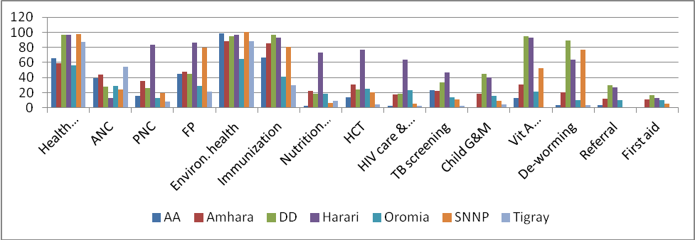
Figure 1: Respondents’ knowledge of specific services by region, 2017

Utilization of urban health extension services: Respondents were asked if they have used urban health extension services – the results are shown in Figure 2. As the Figure shows, service packages reported to have been used most include: environmental health (75.7%), health education (56.5%) and immunization of children (39.2%). On the other hand, services such as first aid (2.2%), referral (3.1%), HIV/AIDS care and support (3.7%), postnatal care (7.8%) and nutritional screening of children (9.7%) seem to have very low rates of utilization. In terms of regional variation, respondents in Addis Ababa and Amhara reported relatively higher utilization of environmental health services, while those from SNNP and Tigray reported relatively higher utilization of health education, as well as environmental health services.

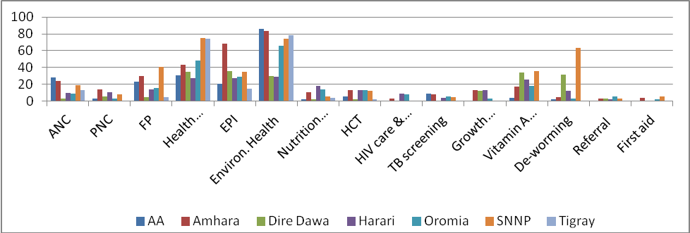

Figure 2: Proportion of households reporting utilization of specific services by region, 2017

Perceived changes after introduction of UHE services: Table 7 below shows the respondents’ assessment of the benefits of, and the changes made as a result of, the urban health extension services. Overall, the responses seem positive in terms of bringing benefits (88%), increasing health awareness (79.2%), increasing health-seeking behavior (79.1%), and overall change in terms of status after the introduction of the urban extension services (87.6%).

Table 7: Perceived changes after introduction of UHE services by region, 2017
Type of service | Region/City administration
Type of service | Addis  Ababa | Amhara | Dire Dawa | Harari | Oromia | SNNP | Tigray | Total
Type of service | n | n | n | n | n | n | n | n | %
Respondents think they benefited from UHE-ps services?
Yes | 80 | 99 | 43 | 29 | 58 | 79 | 81 | 469 | 88
No | 8 | 17 | 11 | 1 | 20 | 1 | 6 | 64 | 12
Respondents think the UHE addressed their information needs?
Yes | 71 | 87 | 33 | 27 | 58 | 71 | 81 | 428 | 77
No | 16 | 29 | 20 | 3 | 44 | 9 | 7 | 128 | 23
Respondents think their health awareness has increased due to UHE?
Yes | 80 | 95 | 28 | 28 | 49 | 78 | 80 | 438 | 79.2
No | 6 | 21 | 26 | 2 | 51 | 2 | 7 | 115 | 20.8
Respondents think health-seeking behavior increased after UHE?
Yes | 78 | 94 | 28 | 29 | 54 | 76 | 77 | 436 | 79.1
No | 7 | 21 | 25 | 1 | 46 | 4 | 11 | 115 | 20.9
Respondents think there are changes in health status after UHE?
Yes | 81 | 104 | 48 | 27 | 65 | 76 | 80 | 481 | 87.6
No | 3 | 12 | 5 | 3 | 35 | 2 | 8 | 68 | 12.4

On the other hand, when the respondents were probed regarding the changes made within specific service categories, the reported perceived changes seem to be very low, except in the case of waste disposal (74.7%). Positive responses to other service categories were very low, such as 13.9% in nutrition as well as adolescent reproductive health, 12.9% in HIV/TB and STI control, 10% in insect/rodent control, 5.6% in control of non-communicable diseases, and 3.2% in first aid measures.

Overall satisfaction with UHE-ps visits: Household respondents were asked about their satisfaction with their last visits to UHE-ps. There were a number of questions asked on this item for triangulation of the responses. These issues included: whether respondents got the services they wanted; how they rate the quality of services they received; the extent to which the services received met their health needs; availability of needed medical apparatus for the services; referral for consultations when needed; friendliness and courtesy of UHE-ps; provision of appropriate time for examination; and whether the services received have helped in dealing effectively with health problems. Accordingly, more than 40% of the survey households responded as being satisfied or very satisfied with most of the items, except for: availability of UHE-ps for home visits (29.4% satisfied and 4% very satisfied); availability of medical supplies (12.9% satisfied and 3% very satisfied);and referrals for consultations (30.2% satisfied and 6.1% very satisfied). The availability of UHE-ps for home visits (47.3% dissatisfied or very dissatisfied) and availability of medical apparatus (45.5% dissatisfied or very dissatisfied) were items for which respondents expressed relatively higher levels of dissatisfaction.

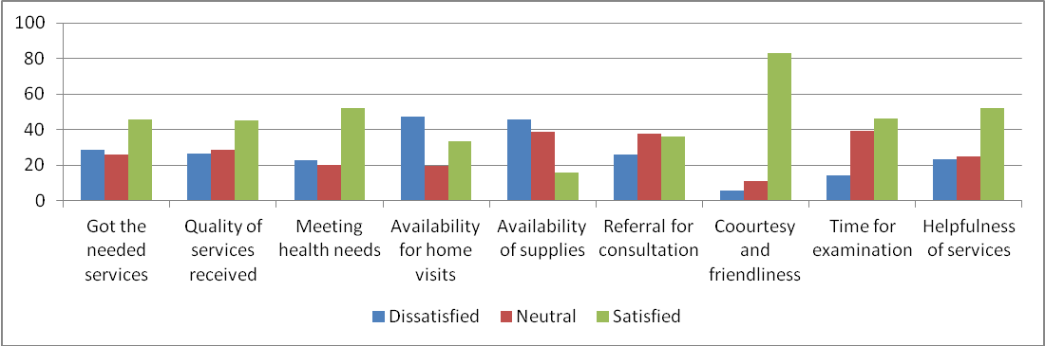

Figure 3: Overall satisfaction of respondents on last visit to UHE-ps, 2017

Discussion
This part of the study attempted to provide information on the quality of the urban health extension services through a quantitative survey of beneficiary communities using Donabedian’s framework (8,9) for assessing outcome quality, i.e., conducting a client satisfaction survey. Based on that framework, the findings of the study show that client households surveyed seem to have positively appraised the benefits and the changes made by the implementation of some of the major components of the program. The outputs from these program components are also said to have led to an increase in health-seeking behavior by communities. About 89.4% of respondent households were aware of environmental health and 76.3% about health education activities by UHE-ps. Moreover, the utilization of environmental health and health education were services were 75.7% and 56.5%, respectively. These major components (health education, environmental health and communicable diseases control) are obviously those in which historically a lot of investments were made during the implementation of primary health care over the last three to four decades (10). Moreover, health education and coordination of environmental sanitation are activities for which beneficiary communities have very high awareness, as well as relatively high utilization rates, across the study regions.

On the other hand, client satisfaction seems rather low with the services that have recently been integrated into the function of community-level health workers: nutrition supplementation and adolescent reproductive, HIV/TB and STI control, non-communicable diseases control, and first aid measures. This is evidenced by the fact that positive responses from the community with regard to perceived changes to the latter category of services were low (13.9% in nutrition as well as adolescent reproductive health, 12.9% in HIV/TB and STI control, 10% in insect/rodent control, 5.6% in control of non-communicable diseases, and 3.2% in first aid measures). Therefore, this shows that the program still needs to work more on integrating and institutionalizing these new functions to the grass-roots level of the health system.

Conclusions
Outcome-related quality is witnessed only in limited parameters of client interaction and provision of preventive care services. The level of satisfaction expressed by clients as well as by UHE-ps is very limited on some services that are critical to the wellbeing of mothers and children. On the other hand, most community members seem to have a good attitude towards the program as well as towards program personnel.
Beneficiary communities seem to have an overall positive impression of the services provided by the UHEP, even though knowledge about and utilization of some of the services seems to be minimal. There are tendencies among many community members of associating the program with kebele political activities. There are also instances where communities expect too much from the urban health extension professionals (UHE-ps), while some others tend to undermine the knowledge and skills of UHE-ps and to not consider them as health professionals.

Therefore, monitoring the knowledge and attitude of the community about services would help to identify factors that are important for optimal utilization of provided services. Caution should also be taken so that health services activities are decoupled from politically motivated initiatives.

References
- Federal Ministry of Health. Manual for implementation of the Urban Health Extension Program (UHEP). Revised. Addis Ababa; FMOH, 2016.
- Federal Ministry of Health. Health Extension Program in Ethiopia. Addis Ababa: FMOH, 2013.
- Donabedian A. Explorations in quality assessment and monitoring: The definition of quality and approaches to its assessment. Ann Arbor, Michigan: Health Administration Press, 1990.
- Institute of Medicine. Measuring the quality of health care: A statement by The National Roundtable on Health. Edited by Donaldson MS. Washington, D.C: National Academy Press, 1999.
- Aldana JM, Piechulek H, Al-Sabir A. Client satisfaction and quality of health care in rural Bangladesh. Bulletin of the World Health Organization. 2001;79(6):512-17.
- Lazakidou A, Daskalaki A (eds.). Quality assurance in healthcare service delivery. Nursing and personalized medicine: Technology and process. USA: Medical Science Information Reference, 2012.
- Sibamo EL, Berheto TM. Community satisfaction with the urban health extension service in South Ethiopia and associated factors. BMC Health Services Research (2015) 15:160 DOI 10.1186/s12913-015-0821-4.
- Donabedian A. The quality of care: How can it be assessed? JAMA 1988;260(12):1743-8.
- Donabedian A. Evaluating the quality of medical care. Milbank Q. 2005;83(4):691-729.
- Federal Ministry of Health. Primary health care review. Addis Ababa: Planning and Programming Department, FMOH, 1985.

